DI BLOYE
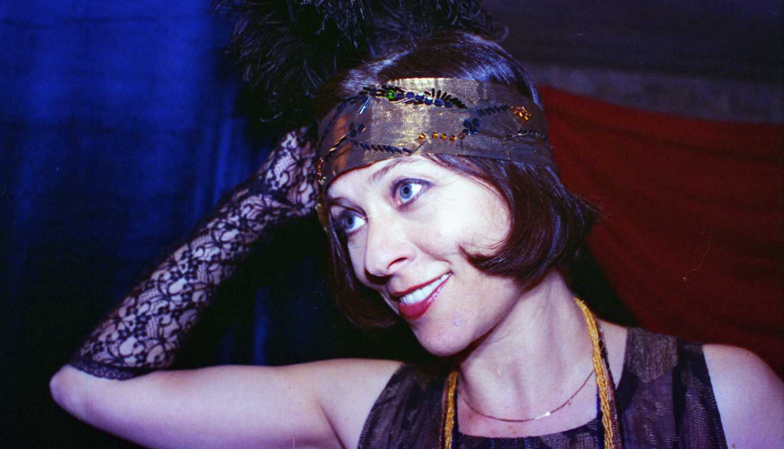

KATZ

Yiddish Cabaret: THE BLUE CAT

Yiddish Tango, Foxtrot, Boston Valse and Charleston!

The couple on stage, Ruth Levin and Avishai Fisz, are two
Israeli artists who have been performing in Europe for several years now. Together they created a gem of genuine music from the Twenties and the Thirties, all in glatt Yiddish!… accessible to the non-Yiddish speaking audience thanks to the humorous and charming English translations uttered by the often over dramatic primadonna of the Warsaw pre-war Yiddish Cabaret, Ms Ewa Przyziszka. Understandably, she is a femme fatale, n’est-ce-pas?! At the piano, her partner and admirer, the world famous Maestro Arturo Fogacz-Bergamescu. Together they produce the most delightful stage presence and enact a fine and artistic musical journey.
Ruth Levin, recipient of the Segal Prize for Yiddish culture,and a leading Israeli interpreter of Yiddish songs, is the daughter of the well-known Czernowitz-born actor and composer Leibu Levin, called “the Yiddish Schubert”. One of his wonderful melodies will be heard in this piece.
Avishai Fisz, an acclaimed actor and highly talented musician, has spread his reputation in Yiddish Folkmusic all over the world. His arrangements for this piece are as creative as they are brilliant. The evening contains authentic Yiddish tango, rumba, waltz and foxtrot songs of the 20’s-30’s, alongside with new Yiddish translations of known and beloved oldies.

...On a small stage, somewhere between Paris and Warsaw,
two stage artists put on their who knows how many times played show.The singer is Ewa Przyżiszka - a primadona of the finest vintage, who masters all the gestures and mimics of a real diva. Her pianist – Arturo Fogacz-Bergamescu, although terrified by her, adores her talent and supplies her with most vivid and sophisticated piano accompaniment. Ewa Przyżiszka moderates the show in (a kind of) English, with a heavy Polish accent and full of funny mistakes, but the loving audience is not bothered by the mistakes, on the contrary - everybody just falls
for this very unique, charming Jewish diva…

